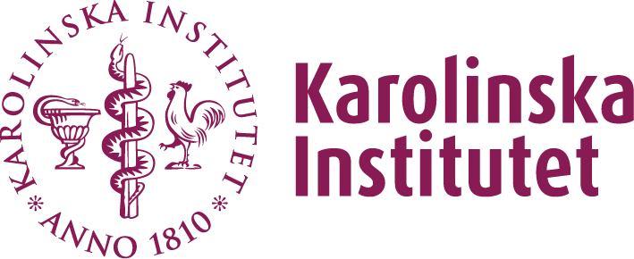

Altering the disease course in neuropsychiatric disorders

ECNP mini-symposium
29 January 2016, 15.00-17.00
Wallenbergsalen, Nobel Forum, Stockholm

Introduction
The general goal of the ECNP mini-symposium is to facilitate the diffusion of cutting-edge research and clinical practice.

Everyone interested in the below topics is invited to attend the meeting. Please send an e-mail before 1 January 2016 to Per Svenningsson (Per.Svenningsson@ki.se) to register for this meeting.
Registration is free of charge and will be handled on a first come first served basis.

Programme

Chairs: Sven Ove Ögren, Clara Gumpert Hellner, Sweden

14.30 Registration opens

15.00 Introduction and mission of ECNP
Per Svenningsson, Stockholm, Sweden

15.10 Altering the course of Schizophrenia: challenges and opportunities
Mark Millan, France

15.50 Gene and vaccine therapies in neuropsychiatry
Åsa Petersen, Lund, Sweden

16.20 Brain stimulation therapies in mood disorders
Anders Tingström, Lund, Sweden

16.50 Summary and closure
Aleksander Mathe, Stockholm, Sweden

17.00 Drinks & networking

